**Sister A’s Rolling Rapids**

**Site Plan**

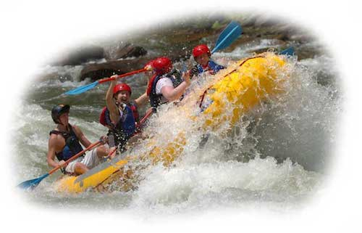

Trish Adelsperger

WDD100-section 13

**Overview**

Site Purpose

At Sister A’s Rolling Rapids, we want to portray that we are the best at what we do, which is delivering supreme rafting adventure experiences. Also that an unforgettable trip with us will be a thrill of a lifetime, and that rafting is for (almost) all ages. Singles, families, groups of friends, work retreats, we serve them all.

We want a clear description of the packages we offer, easy to find custom package contact information, clearly seen and easily added ancillary goods and services. We want our clients to be able to schedule their trip, add upsell items, sign waivers, and pay for it all in one sitting.

The goal is that the result of doing these things will increase our revenue and exposure, and lead to a reputation of a premiere recreation destination.

Target Audience

Our target audience is middle to upper class singles and families, as well as businesspersons and companies looking for incentive/reward/teambuilding retreat experiences. Our clientele are anywhere from weekend warrior to thrill-seeker, with active to semi-active lifestyles.

These people are looking for a place to bond with others, a place to challenge themselves through activity, a place to unplug and reconnect with nature. A place to get away from the daily fast-paced grind of work, all in one package.

They need time to de-stress. They need time with their loved ones. They need a timeout from life. They need a fast way to reserve time for recreation.

Laptops and phones are probably the most popular way to see our site with the clientele we want to attract. They are on the run most of the time, and mostly use their wireless devices and laptops to access the internet.

**Branding**

Website Logo

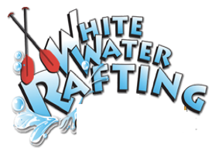

**Color Palette**

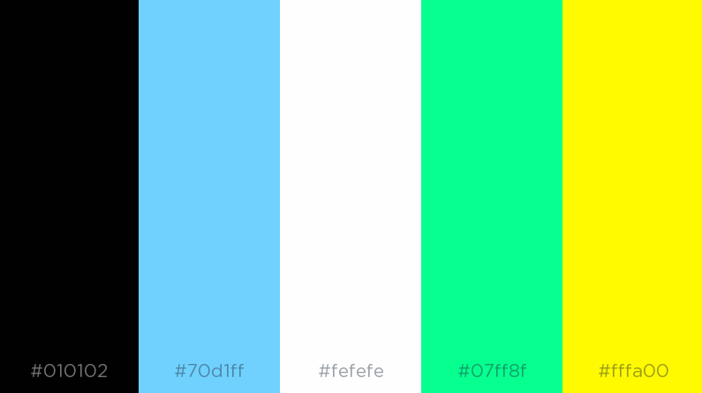

|  |  |  |  |  |
| --- | --- | --- | --- | --- |
| **Primary** | **Secondary** | **Accent** | **Accent** | **Accent** |
| #010102 | #70D1FF | #FEFEFE | #07FF8F | #FFFA00 |

**Typography**

Heading Font

**Font-family: Bradley Hand, color #FEFEFE or #010102 (white or black), 26px, style: italic**

Sister A’s Rolling Rapids

ABCDEFGHIJKLMNOPQRSTUVWXYZ  
abcdefghijklmnopqrstuvwxyz  
1234567890!@#$%^&*()_+

Body Copy Font

**Font-family: Papyrus, color #FEFEFE or #010102 (white or black), 18px**

We believe that there is nothing like a river trip for relaxing. That is why we subscribe to the dry oar philosophy of boating. Keeping your oars dry for us means taking time to look around and notice the beauty that surrounds the rivers we love.

**Navigation**

Main Navigation

|  |  |  |
| --- | --- | --- |
| Home | Rivers and Rates | About Us |

Links

Link:normal : #FEFEFE

Link:hover : #010102

**Layout**

Site Map

**Home**

**Rivers and Rates**

**About Us**

**Layout**

Sister A’s Rolling Rapids Home Page Wireframe

